Synthesis of two 3,5-Disubstituted Δ²-isoxazolines
Ethan Bodak
Adolph Coors Foundation Scholar
Frontiers of Science Institute

ABSTRACT
Macrophage migration inhibitory factor (MIF) has proven to be the leading cause of
most autoimmune diseases and chronic inflammatory conditions. Drugs categorized as isoxazolines have recently been synthesized and proven to inhibit MIF in mice. There has been much debate as to which derivatives of the isooxazoline structure work the best, and which reactants are ideal for high yields. Recent research suggests that a promising synthesis involves a Grignard reaction of an aldehyde with a metalloid followed by oxidation of an alcohol with the 3-buten-1-ol functional group with pyridinium chlorochromate (PCC) to form a ketone with the functional group 3-buten-1-one. The ketone is then treated with a hydroxylamine and a form of acetate. The final synthesis involves a cyclization to close the isoxazole ring, thus creating a form of isoxazoline. This process is relatively cost-effective and produces fairly high yields. Moreover, drugs produced this way have shown promising capabilities in combating MIF.

TABLE OF CONTENTS
I. INTRODUCTION………………………………………………………………………….…...3
II. REVIEW OF LITERATURE…………………………………………………………………..4
III. METHODS AND MATERIALS…………………………………………………………..….5
Overview…………………………………………………………………………………..5
Step 1: Synthesis of 1-(4-methoxyphenyl)-3-buten-1-ol through a Grignard Reaction…..5
Step 2: Synthesis of 1-(4-methoxyphenyl)-3-buten-1-one through oxidation……………1
Step 3: Synthesis of (1E)-N-hydroxy-1-(4-methoxyphenyl)-3-buten-1-imine through an oxime reaction……………………………………………………………………………..4

Step 4.a: Synthesis of nickel-based 3,5-Disubstituted Δ²-isoxazoline through a cyclization process………………………………………………………………………………….…6

Step 4.b: Synthesis of palladium-based 3,5-Disubstituted Δ²-isoxazoline through a cyclization process………………………………………………………………………...8

Product Analysis…………………………………………………………………………..9
IV. RESULTS AND DISCUSSION…………………………………………………………..…10
Results of Grignard reaction……………………………………………………………..10
Results of oxidation reaction………………………………………………………….…11
Results of oxime reaction………………………………………………………………..12
Results of nickel cyclization……………………………………………………………..14
Results of palladium cyclization…………………………………………………………14
Discussion of Results…………………………………………………………………….15
V. FUTURE STUDIES…………………………………………………..………………………16
VI. WORKS CITED……………………………………………………………………………..17

INTRODUCTION
Macrophage migration inhibitory factor (MIF) is responsible for many chronic inflammatory and autoimmune diseases, including multiple sclerosis, type 1and type 2 diabetes, Crohn's disease, lupus, rheumatoid arthritis, and even cancer. Not only can several of these lead to death (cancer being one of the leading causes of death worldwide), but all of them are very common and very difficult to treat. MIF functions as a proinflammatory cytokine involved in most inflammatory reactions, as well as promotes the release of insulin, thus earning its place as a primary cause of diabetes.⁶ Drugs have been synthesized to deal with the symptoms of these various diseases, but an alarming percent of them have failed to deal with the central cause—MIF.
Multiple drugs categorized as isoxazolines have been proven to inhibit MIF in mice (especially one called ISO-1), and are therefore potential treatments for these various inflammatory diseases.² The synthetic methods currently used to produce isoxazolines, however, have either yielded very little product, or have proven very costly to perform. There has been recent research conducted suggesting alternative synthesis reactions involving Grignard, oxidation, and cyclization reactions, but there is still debate as to which reactants will lead to the most desired products, and which derivatives work the best in these reactions.
Many forms of these isoxazolines have been synthesized, and all of them have been proven to inhibit MIF. There are very few known studies regarding the specific isoxazolines with which this paper is concerned (3,5-Disubstituted Δ²-isoxazolines), but the product includes the same isoxazole ring that has shown to be an effective MIF inhibitor in the other forms of isoxazoline such as ISO-1. Moreover, the synthesis reactions required to from this specific isoxazoline can be done with fairly inexpensive reactants, and so can potentially be commercialized on a large enough scale to treat the vast number of people suffering from inflammatory and autoimmune diseases caused by MIF.

REVIEW OF LITERATURE
Many research has already been conducted on isoxazolines and their ability to suppress MIF.^{1,2,3,7,8} Current research supports most isoxazolines as MIF inhibitors and verifies their capability to shield β-cells in the pancreas. Similar research has found that isoxazolines and ISO-1 in particular inhibit MIF by binding to the catalytic sites of the macrophage inhibitor, thus decreasing its activity and protein production.^{3,8} This is supported by various other research and is agreed upon by most biochemical engineers dealing with isoxazolines. There is much debate, however, as to the best way to synthesize and produce these isoxazolines, as well as what the ideal reactants are.
More recent research suggests that the ideal way to synthesize isoxazolines involves a Grignard reaction of an aldehyde with a metalloid followed by oxidation of an alcohol with the 3-buten-1-ol functional group with pyridinium chlorochromate (PCC) to form a ketone with the functional group 3-buten-1-one. The ketone is then treated with a hydroxylamine and a form of acetate. The final synthesis involves a cyclization to close the isoxazole ring, thus creating a form of isoxazoline. This research also mentions such reactions as producing a relatively impressive and fairly controllable yield, as well as being surprisingly cost-effective.^{1,2} The only factor still up for debate is which derivatives connected to the various reactants work the best and provide the most effective product.

METHODS AND MATERIALS
Main Reaction: Synthesis of two 3,5-Disubstituted Δ²-isoxazolines

Overview
The synthesis of two separate 3,5-Disubstituted Δ²-isoxazolines described below was performed in a multi-step process beginning with three steps, in which the starting material p-anisaldehyde was reacted with allylmagnesium chloride to form the alcohol 1-(4-methoxyphenyl)-3-buten-1-ol. In Step 2, the alcohol was reacted with pyridinium chlorochromate to form the ketone 1-(4-methoxyphenyl)-3-buten-1-one. In the third step, the ketone was reacted with hydroxylamine hydrochloride to form (1E)-N-hydroxy-1-(4-methoxyphenyl)-3-buten-1-imine. In the final cyclization steps, two different disubstituted Δ²-isoxazolines were made: the first was made by reacting nickel (II) chloride with (1E)-N-hydroxy-1-(4-methoxyphenyl)-3-buten-1-imine, yielding a nickel-based isooxazoline; the second isoxazoline was made by reacting palladium (II) chloride with (1E)-N-hydroxy-1-(4-methoxyphenyl)-3-buten-1-imine.
Step 1: Synthesis of 1-(4-methoxyphenyl)-3-buten-1-ol through a Grignard Reaction
0.9 mL p-anisaldehyde (Figure 1.a) was reacted with 12.4 mL allylmagnesium chloride (Figure 1.b) dissolved in 25 mL tetrahydrofuran (THF) (Figure 1.c) under argon gas. The p-anisaldehyde was added to a stoppered round bottom flask with a stir bar under argon, followed by the THF. The allylmagnesium chloride was added to the solution very slowly (approximately 0.5 mL/30 sec) with a needle and syringe in order to keep the reaction contained. The reaction must be anhydrous to keep the reactants from decaying. Figure 1.e shows the setup for this reaction. The reaction stirred and ran for approximately 30 min, at the end of which 1-(4-methoxyphenyl)-3-buten-1-ol (Figure 1.d) had been formed.
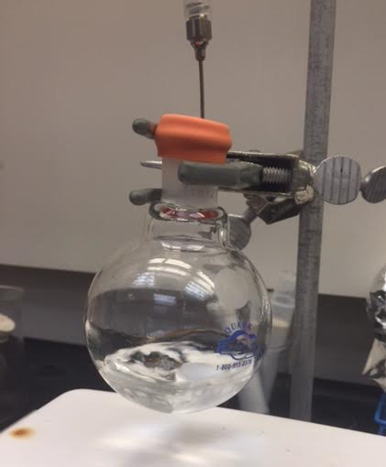
Figure 1.e: setup for Grignard reaction
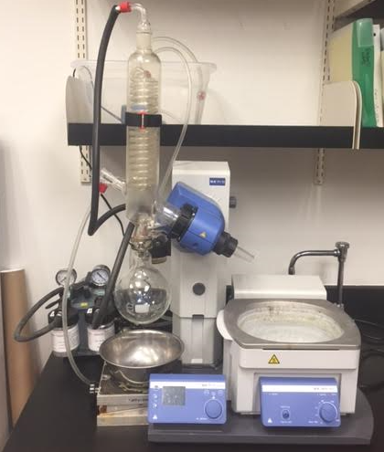
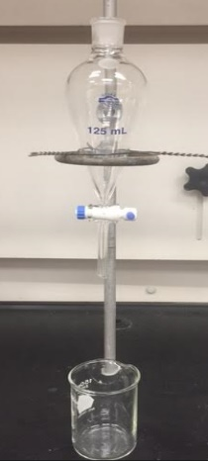
The reaction being complete, deionized water was added to break down any remaining Grignard reagent. A separatory funnel (Figure 1.f) was then used to separate the water from the 1-(4-methoxyphenyl)-3-buten-1-ol. The solution was transferred to the separatory funnel by rinsing out the round bottom with ethyl acetate at least twice. Deionized water and ethyl acetate were added to the separatory funnel to form a clear separation between the aqueous layer (on bottom) containing water with Grignard waste, and the organic layer (on top) containing 1-(4-Methoxyphenyl)-3-buten-1-ol in ethyl acetate. After both layers were washed thoroughly with deionized water and ethyl acetate, the aqueous layer was separated from the organic layer into two separate beakers. The organic layer was transferred to a round bottom flask after rinsing the separatory funnel and beaker with ethyl acetate.
Figure 1.f: separatory funnel Figure 1.g: rotary evaporator
A rotary evaporator (Figure 1.g) was then used to evaporate the remaining ethyl acetate from the 1-(4-methoxyphenyl)-3-buten-1-ol. The temperature was set to approximately 63°C and the pressure was decreased periodically to ensure that all of the ethyl acetate was evaporated from the solution. This process isolated the product 1-(4-methoxyphenyl)-3-buten-1-ol.
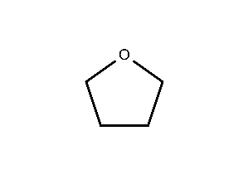
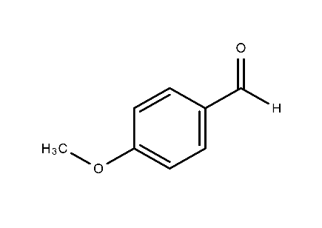
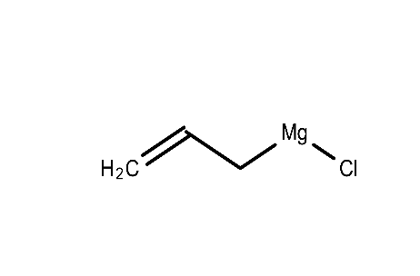

Figure 1.a: p-anisaldehyde Figure 1.b: allylmagnesium chloride Figure 1.c: tetrahydrofuran
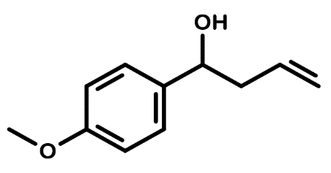

Figure 1.d: 1-(4-methoxyphenyl)-3-buten-1-ol

Step 2: Synthesis of 1-(4-Methoxyphenyl)-3-buten-1-one through oxidation
1-(4-methoxyphenyl)-3-buten-1-ol was reacted with pyridinium chlorochromate (PCC) (Figure 2.a) in dichloromethane (Figure 2.b) in a round bottom flask with a stir bar. Magnesium sulfate was also added to smooth the oxidation. Bellow illustrates the calculation to determine how much PCC and magnesium sulfate was used in the reaction:
The Grignard reaction yielded 0.7861 g of 1-(4-methoxyphenyl)-3-buten-1-ol. 178.25 g/mol was used as the molar mass of 1-(4-methoxyphenyl)-3-buten-1-ol, 215.55 g/mol as the molar mass of PCC, and 1.5:1 as the molar ration of PCC to 1-(4-methoxyphenyl)-3-buten-1-ol.
$$0.7861 gOH × \frac{1 molOH}{178.25 gOH} × \frac{1.5 molPCC}{1 molOH} ×\frac{215.55 gPCC}{1 molPCC}=1.426 gPCC$$
The mass of magnesium sulfate needed is equal to the mass of PCC needed multiplied by five.
$$1.426 gPCC × 5 =7.1305 gMg$$
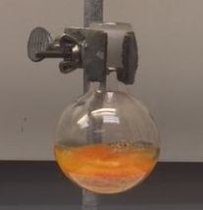
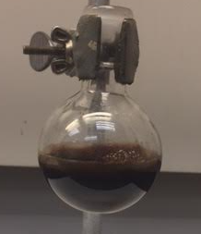
The PCC was mixed with the magnesium sulfate and dichloromethane as the solvent, and then added to a round bottom containing a stir bar. 1-(4-methoxyphenyl)-3-buten-1-ol was then added to the solution. The reaction ran for approximately 1 hour, by the end of which 1-(4-methoxyphenyl)-3-buten-1-one (Figure 2.c) was formed. This was noticeable due to the clear color change of the solution from the start of the reaction to the end (Figures 2.d and 2.e)
Figure 2.d: color of oxidation solution before reaction Figure 2.e: color of oxidation solution after reaction
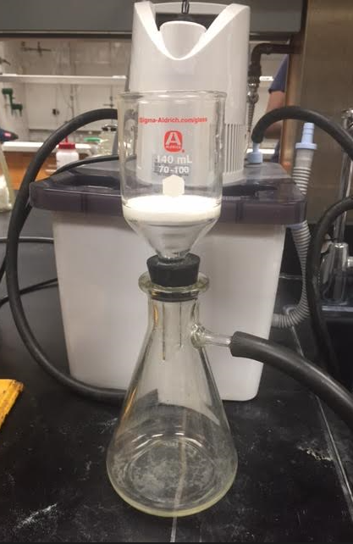
The 1-(4-methoxyphenyl)-3-buten-1-one was then filtered through a filtration funnel containing florisil powder soaked in diethyl ether. The solution was filtered into an Erlenmeyer flask connected to a vacuum pump to pull the solution through the florisil. Figure 2.f shows the setup for this filtration. After the filtration was complete, the 1-(4-methoxyphenyl)-3-buten-1-one dissolved in diethyl ether and was transferred into a round bottom flask after rinsing the Erlenmeyer flask with ethyl acetate. The round bottom was then put through the rotary evaporator set at 20°C to evaporate out the diethyl ether. The pump was set fairly low to ensure that the ether did not boil. Once the diethyl ether was evaporated off, the rotary evaporator was set to 63°C to evaporate off the ethyl acetate and the vacuum pump was increased. This isolated the 1-(4-methoxyphenyl)-3-buten-1-one.
Figure 2.f: setup for oxidation filtration
A chromatotron (Figure 2.g) was then used to purify the 1-(4-methoxyphenyl)-3-buten-1-one even further. A chromatography plate (Figure 2.h) was set on the chromatotron while an 80:20 ratio of hexane to ethyl acetate ran through the plate. Once solution ran through the whole plate, the of 1-(4-methoxyphenyl)-3-buten-1-one was put on the plate using a pipette while the hexanes and ethyl acetate continued to run through the plate. The plate was observed with ultraviolet light and distinct bands of solution started to form (Figure 2.i). The outermost band contained the pure 1-(4-methoxyphenyl)-3-buten-1-one and was collected into a test tube along with the hexanes solution and ethyl acetate.
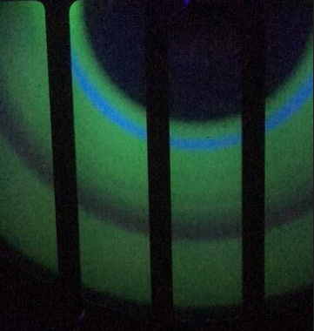
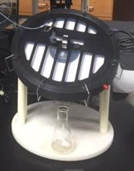
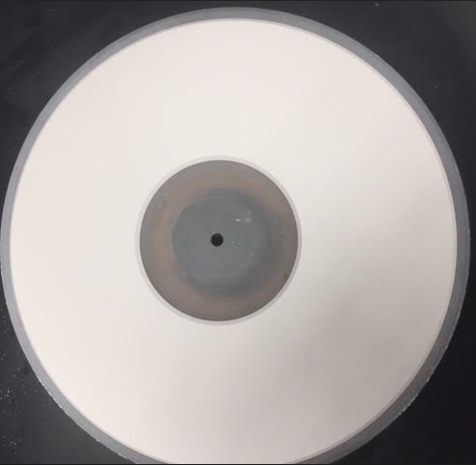
Figure 2.g: chromatotron Figure 2.h: chromatography plate
Figure 2.i: separation of bands on chromatography plate
The band containing 1-(4-methoxyphenyl)-3-buten-1-one in hexanes solution and ethyl acetate was then transferred into a round bottom flask after being rinsed twice with ethyl acetate. The round bottom was connected to a rotary evaporator set at 63℃ to evaporate the hexanes and ethyl acetate from the 1-(4-methoxyphenyl)-3-buten-1-one. This isolated the 1-(4-methoxyphenyl)-3-buten-1-one for the second time.
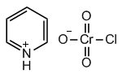
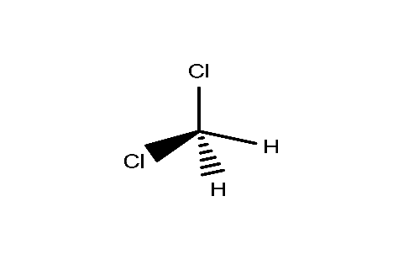

Figure 2.a: pyridinium chlorochromate Figure 2.b: dichloromethane
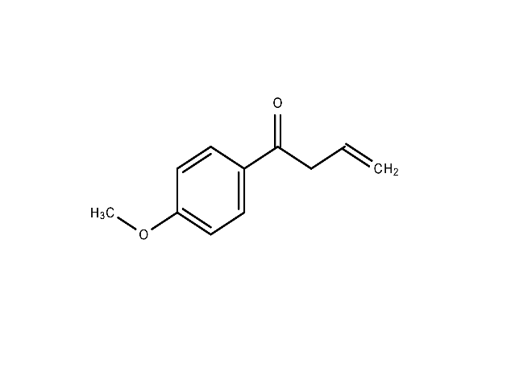

Figure 2.c: 1-(4-methoxyphenyl)-3-buten-1-one
Step 3: Synthesis of (1E)-N-hydroxy-1-(4-methoxyphenyl)-3-buten-1-imine through an oxime reaction

The newly-made 1-(4-methoxyphenyl)-3-buten-1-one in deionized water and ethanol was then reacted with hydroxylamine hydrochloride (Figure 3.a) and sodium acetate trihydrate. Below illustrates the calculations to determine how much sodium acetate and hydroxylamine hydrochloride were needed for the reaction:
The oxidation reaction yielded 0.585 g of 1-(4-methoxyphenyl)-3-buten-1-one. 176.21 g/mol was used as the molar mass of 1-(4-methoxyphenyl)-3-buten-1-one, 82.02 g/mol as the molar mass of sodium acetate, and 8:1 as the molar ration of Sodium acetate to 1-(4-methoxyphenyl)-3-buten-1-one.
$$0.585 gKet × \frac{1 molKet}{176.21 gKet} ×\frac{8 molNa}{1 molKet} ×\frac{82.02 gNa}{1 molNa}=2.1784 gNa$$
$$2.1784 gNa × \frac{1molNa}{82.02 gNa} × \frac{1 molH2O}{1 molNa} ×\frac{136.08 gH2O}{1 molH2O}=3.6142 g Na·3H2O$$
69.49 g/mol was used as the molar mass of hydroxylamine hydrochloride, and 6:1 as the molar ratio of hydroxylamine hydrochloride to1-(4-methoxyphenyl)-3-buten-1-one.
$$0.585 gKet ×\frac{1 molKet}{176.21 gKet} ×\frac{6 molHCl}{1 molKet} ×\frac{69.49 gHCl}{1 mol HCl}=1.3842 gHCl$$
14 mL of a 50:50 ratio of deionized water to ethanol was added to the 1-(4-methoxyphenyl)-3-buten-1-one in a round bottom flask with a stir bar. Sodium acetate trihydrate was then added to the solution, followed by hydroxylamine hydrochloride. The reaction was heated using a heating mantle connected to a variac. The round bottom was topped with a condenser bulb and ran until the solution started to drip from the bulb. This reaction formed (1E)-N-hydroxy-1-(4-methoxyphenyl)-3-buten-1-imine (Figure 3.b); this product was used as the base for the 3,5-Disubstituted Δ²-isoxazolines.
The product was then filtered out using a separatory funnel with deionized water and ethyl acetate. The solution was then transferred to an Erlenmeyer flask by rinsing the round bottom with ethyl acetate, and magnesium salt was added to dry out any remaining water. The solution was then filtered into a round bottom using a funnel and filter paper. The solution was then put through the rotary evaporator at 63°C in order to evaporate off any ethyl acetate. This process isolated the (1E)-N-Hydroxy-1-(4-methoxyphenyl)-3-buten-1-imine.
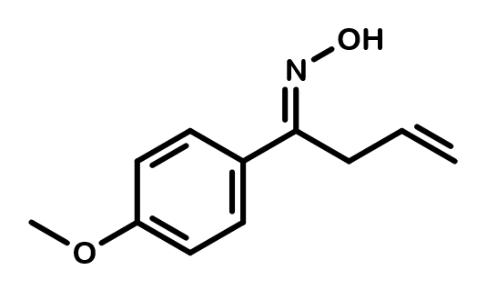
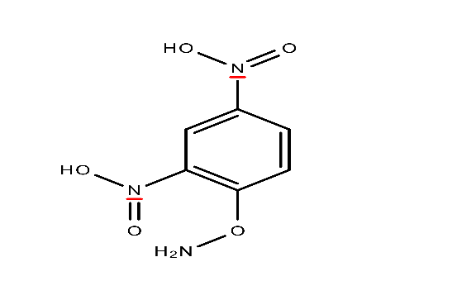
NOTE: Steps1-3 may have to be repeated to produce enough (1E)-N-hydroxy-1-(4-methoxyphenyl)-3-buten-1-imine for both cyclization processes.

Figure 3.a: hydroxylamine hydrochloride Figure 3.b: (1E)-N-hydroxy-1-(4-methoxyphenyl)-3-buten-1-imine

Step 4.a: Synthesis of nickel-based 3,5-Disubstituted Δ²-isoxazoline through a cyclization process

The (1E)-N-hydroxy-1-(4-methoxyphenyl)-3-buten-1-imine in methanol was then reacted with nickel (II) chloride and copper (II) chloride. Bellow illustrates the masses of nickel (II) chloride and copper (II) chloride that were needed for the reaction:
The oxime reaction yielded 0.4997 g (1E)-N-hydroxy-1-(4-methoxyphenyl)-3-buten-1-imine, but only 0.1077 g (about 1/10 g) was used for this reaction. 175.24 g/mol was used as the molar mass of (1E)-N-hydroxy-1-(4-methoxyphenyl)-3-buten-1-imine, 129.593 g/mol as the molar mass of nickel (II) chloride, and 134.446 g/mol as the molar mass of copper (II) chloride. 5:100 was used as the molar ratio of nickel (II) chloride to (1E)-N-hydroxy-1-(4-methoxyphenyl)-3-buten-1-imine, and 300:100 as the molar ratio of copper (II) chloride to (1E)-N-hydroxy-1-(4-methoxyphenyl)-3-buten-1-imine.
$$0.1077 gOx ×\frac{1 molOx}{175.24 gOx} ×\frac{5 molNi}{100 molOx} ×\frac{129.593 gNi}{1 molNi} =0.003982 gNi$$
$$0.107 gOx × \frac{1 molOx}{175.24 gOx} ×\frac{300 molCu}{100 molOx} ×\frac{134.446 gCu}{1 molCu}=0.2479 gCu$$
Approximately 10 mL of methanol was added to the round bottom flask containing (1E)-N-hydroxy-1-(4-methoxyphenyl)-3-buten-1-imine. Nickel (II) chloride was then added, and solution was stirred using a stir bar. Copper (II) chloride was added in last. This reaction must sit for more than 3 hours, but should sit overnight for the reaction to go to completion. The round bottom was lightly stoppered to ensure that no foreign material could get in. This reaction formed the nickel-based 3,5-Disubstituted Δ²-isoxazoline (Figure 4.a).
Once the reaction had run for at least 12 hours, the nickel-based 3,5-Disubstituted Δ²-isoxazoline was then cleaned thoroughly using a separatory funnel. First, the reaction flask was rinsed at least twice with ethyl acetate and poured into the funnel. Then, the solution was rinsed twice with deionized water and ethyl acetate, each time separating the aqueous layer (on bottom) into a waste beaker and the organic layer into a separate beaker. The organic layer was then washed with sodium bicarbonate twice, then with deionized water, and another time with brine solution, each time separating the aqueous layer from the organic. The aqueous layer was then rinsed a final time with deionized water and the layers separated out. Figure 4.b shows the ideal color of the organic layer.
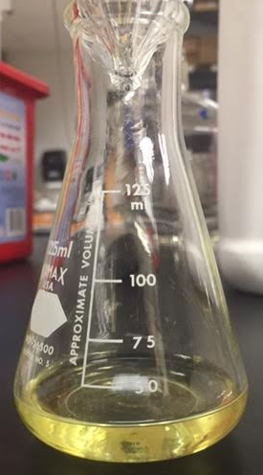
Figure 4.b: color of organic layer containing 3,5-Disubstituted ∆²-isoxazoline
The beaker containing the organic layer (the nickel-based 3,5-Disubstituted Δ²-isoxazoline in ethyl acetate) was then rinsed twice with ethyl acetate into an Erlenmeyer flask and dried with magnesium sulfate. The Erlenmeyer flask was rinsed with ethyl acetate and filtered into a round bottom. The round bottom was then connected to the rotary evaporator set to 63°C and the ethyl acetate was evaporated off. This process isolated the nickel-based 3,5-Disubstituted Δ²-isoxazoline.
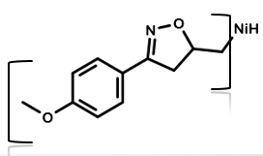
Figure 4.a: nickel-based 3,5-Disubstituted ∆²-isoxazoline
Step 4.b: Synthesis of palladium-based 3,5-Disubstituted Δ²-isoxazoline through a cyclization process

The rest of the (1E)-N-hydroxy-1-(4-methoxyphenyl)-3-buten-1-imine was reacted with palladium (II) chloride and copper (II) chloride in methanol. Described bellow are the calculations to determine the masses of palladium (II) chloride and copper (II) chloride needed for this reaction:
Approximately 1/10 g (0.1154 g) of (1E)-N-hydroxy-1-(4-methoxyphenyl)-3-buten-1-imine was used in the reaction. The molar mass used for (1E)-N-hydroxy-1-(4-methoxyphenyl)-3-buten-1-imine was 191.24 g/mol, 177.31 g/mol was used as the molar mass for palladium chloride, and 134.446 g/mol as the molar mass for copper (II) chloride. 5:100 was used as the molar ratio of palladium (II) chloride to (1E)-N-hydroxy-1-(4-methoxyphenyl)-3-buten-1-imine, and 300:100 as the molar ratio of copper (II) chloride to (1E)-N-hydroxy-1-(4-methoxyphenyl)-3-buten-1-imine.
$$0.1154 gOx ×\frac{1 molOx}{191.24 gOx} × \frac{5 molPd}{100 molOx} × \frac{177.31 gPd}{1 molPd} =0.00535 gPd$$
$$0.1154 gOx × \frac{1 molOx}{191.24 gOx} × \frac{300 molCu}{100 molOx} × \frac{134.446 gCu}{1 molCu} =0.2434 gCu$$
Approximately 11.5 mL of methanol was added to the reaction flask containing (1E)-N-hydroxy-1-(4-methoxyphenyl)-3-buten-1-imine. Then, palladium (II) chloride was added to solution, followed by the copper (II) chloride while the reaction stirred. As with the nickel cyclization, the reaction must run over night. The reaction having gone to completion, the palladium-based 3,5-Disunstituted Δ²-isoxazoline (Figure 4.c) was made.
The solution was then cleaned through a separatory funnel using a similar process for the one described in Step 4.a with deionized water, ethyl acetate, sodium bicarbonate, and brine solution. The color of the organic layer was similar to the one in Figure 4.b. The organic layer was then put through to rotary evaporator at ~63°C, by the end of which the palladium-based 3,5-Disubstituted Δ²-isoxazoline had been isolated.
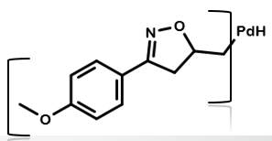
Figure 4.c: palladium-based 3,5-Disubstituted ∆²-isoxazoline
Product analysis
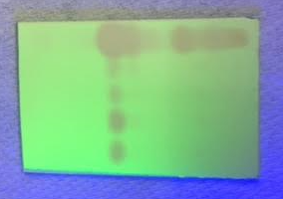
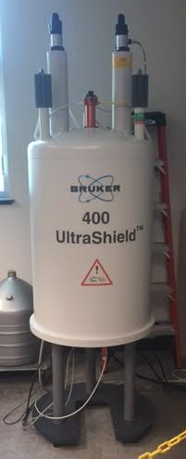
There are many ways to ensure that the products made in each of these reactions are actually the desired products. The two major ways utilized in this research were nuclear magnetic resonance (NMR) (Figure 5.a) and thin layer chromatography (TLC) plates. The specific NMR used was a proton NMR (or hNMR), and the solvent used was chloroform-d. The hNMR should allow the structure to be clearly seen through different peaks in different places on the graph to verify the identity of the compound. The TLC plates were used as an efficient way of comparing the starting material to the product. One drop each of starting material and product was put on the bottom of a TLC plate. The plate was then put in a chromatography jar containing an 80:20 ratio of hexanes solution to ethyl acetate. As the hexanes and ethyl acetate moved up the TLC plate, it dragged the drops with it. The more polar the drop, the less it would move, while the less polar, the more it would move. This can only be observed with ultraviolet light (Figure 5.b). While this did not give the exact identity of the product, it confirmed or denied that something was made.
Figure 5.a: nuclear magnetic resonance machine Figure 5.b: example of thin layer chromatography plate

RESULTS AND DISCUSSION
Results of Grignard reaction
The theoretical yield for the Grignard reaction was calculated to be 1.3092 g 1-(4-methoxyphenly)-3-buten-1-ol. The actual yield was massed to be 0.7861 g, meaning that the percent yield for this reaction was 60.04%.
After the 1-(4-methoxyphenyl)-3-buten-1-ol was purified, a TLC plate was made comparing p-anisaldehyde to 1-(4-methoxyphenyl)-3-buten-1-ol (Figure 6.a). The TLC plate showed that a compound was indeed formed and that it’s polarity is similar to that of 1-(4-methoxyphenyl)-3-buten-1-ol.

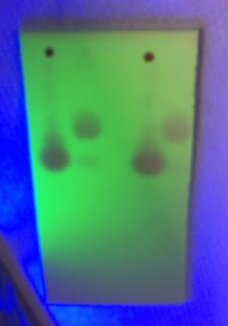
Figure 6.a: TLC plate comparing 1-(4-methoxyphenyl)-3-buten-1-ol (long strands) to p-anisaldehyde (short strands)

A proton NMR was also taken of 1-(4-methoxyphenyl)-3-buten-1-ol (Figure 6.b), verifying that the compound was truly 1-(4-methoxyphenyl)-3-buten-1-ol.
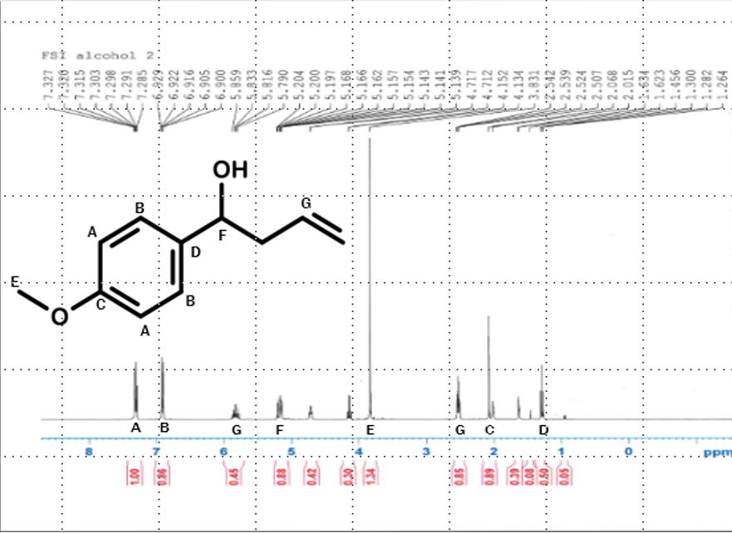
Figure 6.b: proton NMR of 1-(4-methoxyphenyl)-3-buten-1-ol
Results of oxidation reaction
The theoretical yield for the oxidation reaction was 0.7771 g 1–(4-methoxyphenyl)-3-buten-1-one. After the reaction was finished, the end product was weighed to be 0.585 g. Using that as the actual yield, the percent yield for this reaction was determined to be 75.28%.

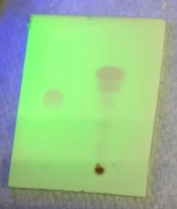
A TLC plate was made comparing the oxidation product and 1-(4-Methoxyphenly)-3-buten-1-ol (Figure 7.a). The plate showed that a compound was formed, and that it was more polar than 1-(4-methoxyphenyl)-3-buten-1-ol (thus resembling 1-(4-methoxyphenyl)-3-buten-1-one).
Figure 7.a: TLC plate comparing 1-(4-methoxyphenyl)-3-buten-1-ol (left) and 1-(4-methoxyphenyl)-3-buten-1-one (right).

A proton NMR was also taken of 1-(4-methoxyphenyl)-3-buten-1-one (Figure 7.b). The NMR verified that the compound made was in fact 1-(4-methoxyphenyl)-3-buten-1-one.
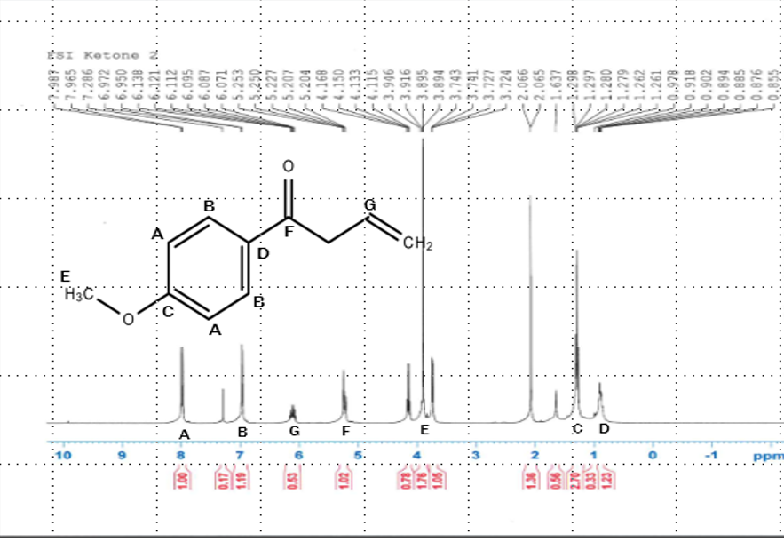
Figure 7.b: proton NMR of 1-(4-methoxyphenyl)-3-buten-1-one

Results of oxime reaction
The theoretical yield for the oxime reaction with the given masses was calculated out to be 0.5818 g (1E)-N-hydroxy-1-(4-methoxyphenyl)-3-buten-1-imine, while the actual yield was 0.4997g, making the percent yield 85.89%.
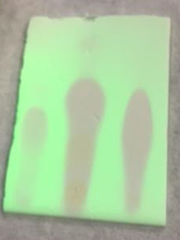
Once the (1E)-N-hydroxy-1-(4-methoxyphenyl)-3-buten-1-imine was purified, a TLC plate was made comparing 1-(4-methoxyphenyl)-3-buten-1-ol, 1-(4-methoxyphenyl)-3-buten-1-one, and (1E)-N-hydroxy-1-(4-methoxyphenyl)-3-buten-1-imine (Figure 8.a). The TLC plate not only showed that something had been synthesized through the reaction, but also showed that the product from the reaction had similar polarity to (1E)-N-hydroxy-1-(4-methoxyphenyl)-3-buten-1-imine.
Figure 7.a: TLC plate comparing 1-(4-methoxyphenyl)-3-buten-1-ol (left), 1-(4-methoxyphenyl)-3-buten-1-one (middle), and (1E)-N-hydroxy-1-(4-methoxyphenyl)-3-buten-1-imine (right)

A proton NMR was also taken of the product (Figure 7.b). The results from the NMR verified that the product mad was indeed (1E)-N-hydroxy-1-(4-methoxyphenyl)-3-buten-1-imine.
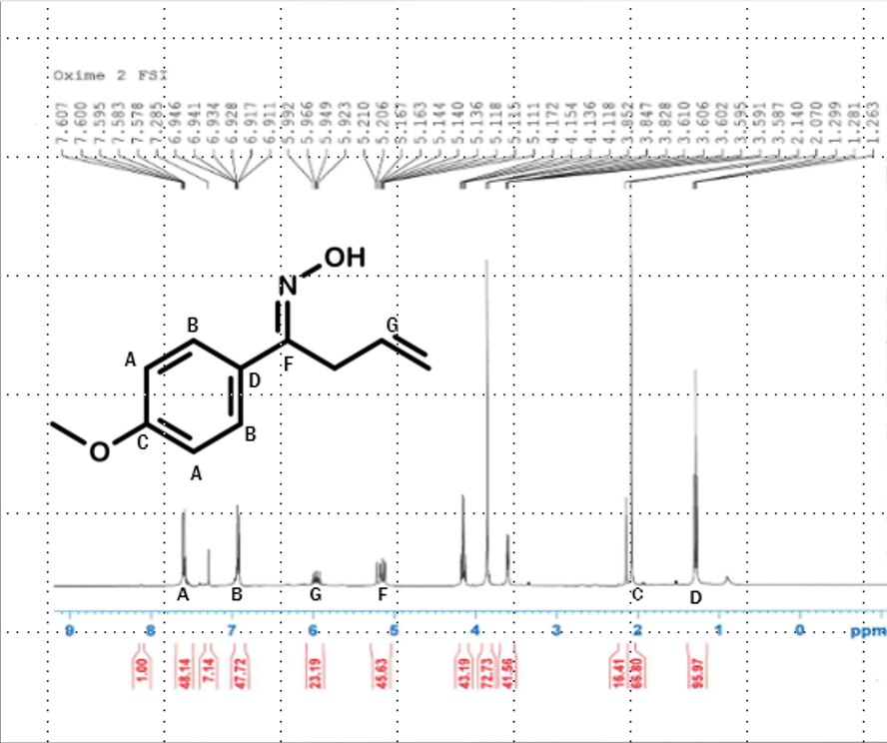
Figure 7.b: proton NMR of (1E)-N-hydroxy-1-(4-methoxyphenyl)-3-buten-1-imine

Results of nickel cyclization
The theoretical yield for the nickel cyclization was 0.153 g of the nickel-based 3,5-Disubstituted ∆²-isoxazoline. The mass of product actually created was 0.1098 g, giving 71.76% as the percent yield for this reaction.
The proton NMR taken of the product (Figure 8) showed that some form of isoxazoline was created, but very little of it. It also showed that the nickel metal most likely fell off of the carbon chain during the reaction.
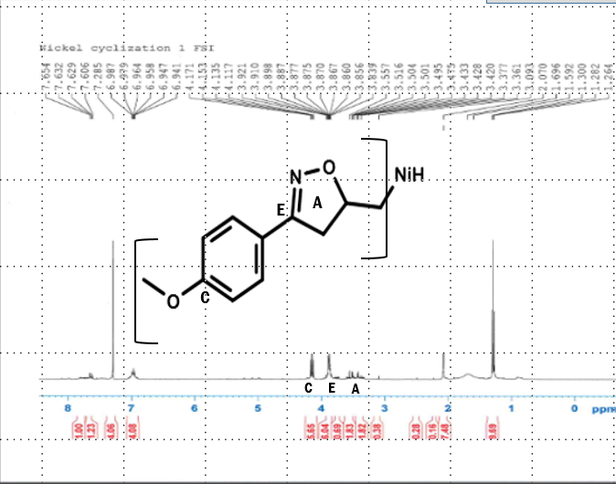
Figure 8: proton NMR of nickel-based 3,5-Disubstituted ∆²-isoxazoline
Results of palladium cyclization
The theoretical yield for the palladium cyclization was 0.1796 g of the palladium-based 3,5-Disubstituted ∆²-isoxazoline. The actual yield was massed out to be __. Using these yields, the percent yield was calculated to be __.
A proton NMR was taken of the product and verified that a relatively pure form of 3,5-Disubstituted ∆²-isoxazoline was made (Figure 9).
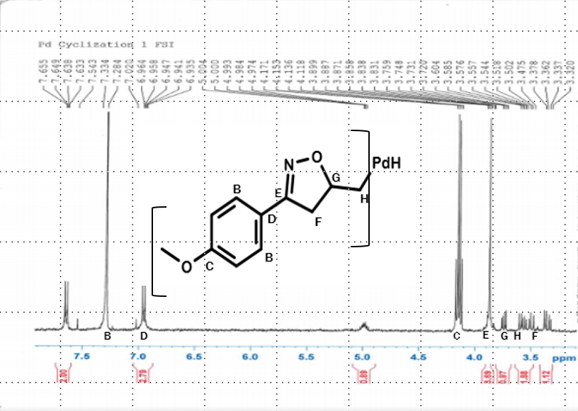
Figure 9: proton NMR of palladium-based 3,5-Disubstituted ∆²-isoxazoline
Discussion of Results
The yields for these reactions are all fairly low, but they increase with each reaction. Because of these results, the most likely explanation is that the yields improved while our skills and techniques improved.
The results also suggest that the nickel (II) chloride did not fully cyclize. There are a number of possible explanations for this. It is possible that the nickel metal does not draw enough electrons to cyclize, or it is possible that the nickel was just not strong enough to stay attached to the isoxazole ring. As always, it is also possible that there was human error in the calculations, and so the masses were unproportional to each other, thus throwing off the whole reaction.
The palladium, on the other hand, cyclized very well and produced a relatively pure form of the 3,5-Disubstituted ∆²-isoxazoline. This could be because the palladium metal draws more electrons than nickel, or because it is stronger and holds the form of the isoxazole ring better than nickel.

FUTURE STUDIES
Cyclization with the nickel derivative has hardly been researched, and it is probable that it will become an area of future study. However, if the nickel proves to be a poor metal when it comes to the cyclization process, many researchers will abandon it. Because the palladium worked so well, it will also be an area of high interest for future scientists. Much more research on 3,5-Disubstituted Δ²-isoxazolines will be performed in the future, all in hopes of determining which derivatives and which reactants work the best to for the isoxazole ring and to inhibit MIF. It is promising that this research will contribute towards perfecting isoxazolines and making them perfect combatants against MIF, a big step against cancer and diabetes.

WORKS CITED
1. Norman, A. L., Shurrush, K. A., Calleroz, A. T., & Mosher, M. D. (2007, July 23). A tandem oximation-cyclization route to ∆²-isoxazolines. Retrieved July 1, 2017, from file:///E:/Article%201.pdf
2. Norman, A. L., Mosher, M. D. (2008, April 22). Enantioselectivity in the synthesis of 3,5-disubstituted ∆²-isoxazolines. Retrieved July 1, 2017, from file:///E:/Article%202.pdf
3. Khoufache, K., Bazin, S., Girard, K., et al. (2012, April 19). Macrophage Migration Inhibitory Factor Antagonist Blocks the Development of Endometriosis In Vivo. Retrieved July 1, 2017, from file:///E:/Article%203.pdf
4. Asare, Y., Schmitt, M., & Bernhagen, J. (2012, December 3). The vascular biology of macrophage migration inhibitory factor (MIF): Expression and effects in inflammation, atherogenesis and angiogenesis. Retrived July 1, 2017, from file:///E:/Article%204.pdf
5. Conroy, H., Mawhinney, L., & Donnelly, S. C. (2010, August 30). Inflamation and cancer: macrophage migration inhibitory factor (MIF)—the potential missing link. Retrieved July 1, 2017, from file:///E:/Article%205.pdf
6. Toso, C., Emamaulle, J. A., Merani, S., Shapiro, A. M. J. (2008, May 12). The role of macrophage inhibitory factor on glucose metabolism and diabetes. Retrieved July 1, 2017, from file:///E:/Article%206.pdf
7. Stojanović, I., Maksimović, D., Al-Abed, Y., et al. (2008). Control of the final stage of immune-mediated diabetes by ISO-1, and antagonist of macrophage migration inhibitory factor. Retrieved July 1, 2017, from file:///E:/Article%207.pdf
8. Al-Abed, Y., VanPatten, S. (2011). MIF as a disease target: ISO-1 as a proof-of-concept therapeutic. Retrieved July 1, 2017, from file:///E:/Article%208.pdf

